This document is intended as a companion tool for typical 2022 local reach codes. It should be modified to suit local requirements (especially blue italicized text).

Version 1.1, February 2023
DELETE ALL BLUE TEXT BEFORE PUBLISHING

The [Jurisdiction Name] has adopted the following local building energy standards. These standards apply to all newly constructed buildings and alterations [modify as needed] with Land Use Permit applications submitted on or after [date] and newly constructed buildings with Building Permit applications submitted on or after [date].
These building standards have been established to ensure that new construction and additions and alterations [modify as needed] in [Jurisdiction Name] are healthier for occupants, have limited impact on the environment, reduce demand for energy, and result in cost savings from building operation over the life of the building.
This summary is intended to highlight the requirements, but each building type has an accompanying checklist detailing the standards. Please include the appropriate checklist with your submittal package.

For more information, please visit [jurisdiction website or other resource]

Single Family Projects
 | New Construction [checklist hyperlink] | Additions or Alterations [checklist hyperlink]
 | Buildings [modify as needed]  - All-electric construction; no gas appliances or infrastructure  - Meet or exceed 2022 Building Energy Efficiency Standards and Green Building Standards Code | Buildings [modify as needed]  Electrification measure compliance  - Gas appliance replaced with electric appliance in accordance with scope of work  - Panel upgrades require pre-wiring for future all-electric appliances  - Electric readiness for laundry and kitchen areas  Energy efficiency measure compliance  - Energy efficiency measures in accordance with scope of work
 | Exceptions [modify as needed and hyperlink form]  - Cooktop  - Pool heater  - Spa heater  - Outdoor barbeque  - Outdoor fireplace | Exceptions [hyperlink form]  - Electrification: gas appliances are not being replaced  - Energy efficiency: buildings constructed before [xxxx]
 | EV Chargers [modify as needed]  - One Level 2 EV Ready space per unit | EV Chargers [modify as needed]  - One Level 2 EV Ready space per unit
 | Exceptions [modify as needed and hyperlink form if applicable]  - No on-site parking | Exceptions [modify as needed and hyperlink form]  - No electrical panel upgrade

Multifamily Projects
 | New Construction [checklist hyperlink] | Additions or Alterations [checklist hyperlink]
 | Buildings [modify as needed]  - All-electric construction; no gas appliances or infrastructure  - Meet or exceed 2022 Building Energy Efficiency Standards and Green Building Standards Code | Buildings [modify as needed]  Electrification measure compliance  - Gas appliance replaced with electric appliance in accordance with scope of work  - Panel upgrades require pre-wiring for future all-electric appliances  Energy efficiency measure compliance  - Energy efficiency measures in accordance with scope of work
 | Exceptions [modify as needed and hyperlink form]  - The facility has approved entitlements before the effective date of the all-electric ordinance  - There is not an all-electric prescriptive compliance pathway for this facility to comply with the California Building Energy Efficiency Standards | Exceptions [modify as needed and hyperlink form]  - Electrification: gas appliances are not being replaced  - Energy efficiency: buildings constructed before [xxxx]
 | EV Chargers [modify as needed]  Small Projects (less than 20 units)  - 10% EV Capable  - 25% Level 2 EV Receptacle  Large Projects (20 units or more)  - 10% EV Capable  - 25% Level 2 EV Receptacle  - 5% EV Chargers | EV Chargers [modify as needed]  - 10% EV Capable upon additions or alterations of parking facilities
 | Exceptions [modify as needed and hyperlink form]  All exceptions in Part 11, Section 4.106.4 apply | Exceptions [modify as needed and hyperlink form]

Nonresidential, Hotel and Motel Projects
 | New Construction [checklist hyperlink] | Additions or Alterations [checklist hyperlink]
 | Buildings[modify as needed]  - All-electric construction; no gas appliances or infrastructure  - Meet or exceed 2022 Building Energy Efficiency Standards and Green Building Standards Code | Buildings [modify as needed]  Electrification measure compliance  - Gas appliance replaced with electric appliance in accordance with scope of work  - Panel upgrades require pre-wiring for future all-electric appliances  - Electric readiness for laundry and kitchen areas  Energy efficiency measure compliance  - Energy efficiency measures in accordance with scope of work
 | Exceptions [modify as needed and hyperlink form]  - Commercial kitchen  - Essential facility, hospital, or laboratory  - Process loads  - No viable compliance category | Exceptions [modify as needed and hyperlink form]  - Electrification: gas appliances are not being replaced  - Energy efficiency: buildings constructed before [xxxx]
 | EV Chargers [modify as needed]  - See Tables 1 and 2 | EV Chargers [modify as needed]
 | Exceptions [modify as needed and hyperlink form]  - All exceptions in Part 11, Sections 4.106.4 and 5.106.5.3 apply | Exceptions [modify as needed and hyperlink form]

Table 1: Hotel and Motel New Construction EV Charging Requirements [modify as needed]
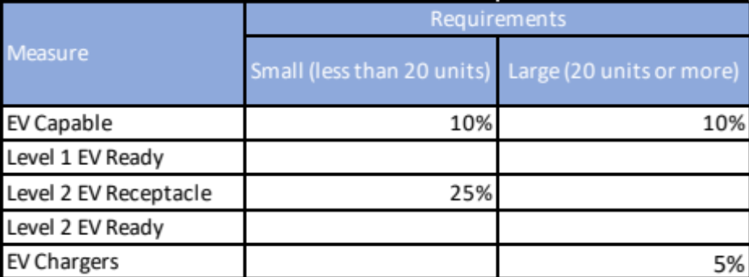

Table 2: Other Nonresidential New Construction EV Charging Requirements [modify as needed]
Total Number of Actual Parking Spaces | Required EV Level 1 Spaces | Required EV Level 2 Spaces | Required EV Capable Spaces | Required Spaces with Chargers | Total EV Spaces
0–9 |  |  | 0 | 0 | 0
10–25 |  |  | 4 | 0 | 4
26–50 |  |  | 6 | 2 | 8
51–75 |  |  | 10 | 3 | 13
76–100 |  |  | 13 | 4 | 17
101–150 |  |  | 19 | 6 | 25
151–200 |  |  | 26 | 9 | 35
201 and over |  |  | 15% of total | 5% of total | 20% of total
Off Street Loading Spaces | Refer to CALGreen Table 5.106.5.4.1

DEFINITIONS [Add or delete or modify terms to conform to the ordinance. Note, EV charging definitions are not written as they appear in the State Code but have been modified to suit the context of the requirements by occupancy.]

ADDITIONS OR ALTERATIONS (BUILDINGS) [insert local definition]

ADDITIONS OR ALTERATIONS (PARKING FACILITIES). Addition of new parking facilities or addition or alteration of electrical systems at existing parking facilities.

AUTOMATIC LOAD MANAGEMENT SYSTEM (ALMS). A system designed to manage load across one or more electric vehicle supply equipment (EVSE) to share electrical capacity and/or automatically manage power at each connection point.
EV CAPABLE SPACE. A vehicle space capable of supporting future EV charging, which includes raceway and/or sheathed cable, panel capacity and circuit breaker space for a 208/240 volt 40 amp minimum branch circuit.
EV CHARGER. Off-board charging equipment used to charge an electric vehicle connected to a 208/240 volt 40 amp minimum circuit. If using an automated load management system (ALMS), each charging port shall deliver a minimum 30 amperes to an EV when charging one vehicle and shall deliver a minimum 3.3 kW while simultaneously charging multiple EVs.
LEVEL 1 EV READY. A parking space that is served by a complete electric circuit with the following requirements:
- A minimum of 2.2 kVa (110/120 volt, 20-ampere) capacity wiring.
- A receptacle labeled “Electric Vehicle Outlet” or electric vehicle supply equipment (EVSE) located within three (3) feet of the parking space. If EVSE is provided the minimum capacity of the EVSE shall be 16-ampere.
- Conduit oversized to accommodate future Level 2 EV Ready (208/240 volt, 40-ampere) at each parking space.
LEVEL 2 EV READY. A parking space that is served by a complete electric circuit with the following requirements:
- A minimum of 8.3 kVa (208/240 volt, 40-ampere) capacity wiring.
- A receptacle labeled “Electric Vehicle Outlet” or EVSE located within three (3) feet of the parking space. If EVSE is provided the minimum capacity of the EVSE shall be 30-ampere.
LEVEL 2 EV RECEPTACLE. A 208/240-volt 20 amp minimum branch circuit and a receptacle for EV charging.

NEW CONSTRUCTION [insert local definition]

